MEASUREMENTS OF NEUTRON TOTAL CROSS SECTIONS OF HAFNIUM AND ZIRCUNIUM AT THE POHANG NEUTRON FACILITY
_______________________________________________________________A.K.M. Moinul Haque Meaze
Student ID: 2003419008
Center for High Energy Physics, Kyungpook National University
Daegu-702-701, Republic of Korea

In order to obtain neutron total cross section, transmission experiments were carried out on the samples of Hafnium (Hf) and Zirconium (Zr) at the Pohang Neutron Facility (PNF). A ⁶Li-ZnS(Ag) scintillator detector and time of flight technique were used to measure the transmission. The PNF consists of 100 MeV electron linac, a water cooled Ta target and four position automatic sample changer controlled remotely by CAMAC data acquisition system. The distances from the water cooled Ta target to the sample changer and to the scintillator are 5.4m and 10.8m respectively. Notch filter consists of Co, In and Cd which has a large resonance peaks in the spectrum to determine the background levels. To reduce gamma flash originated from the neutron target we have employed a neutron-gamma separation system based on their different pulse shape. We covered the energy range 0.1eV≤E_{n}≤100eV.The present measurements were compared with the evaluated nuclear data in ENDF/B-VI [1].
I. INTRODUCTION
Neutrons provide a useful tool treat a number of questions from the domain of particle physics, nuclear physics, quantum physics and measurement theory. Further several neutrons –nuclear methods exist, which are or may become helpful in the applied and industrial sciences. Information about the relative probabilities of different reactions provides clues to the problem of nuclear structure and offers a testing ground for ideas about nuclear forces. So cross section is used to obtain information about the internal structure of atomic nuclei and their constituents. The possibility of achieving a chain reaction and to design and development of a nuclear reactor depend strongly on the values of neutron cross section. Hafnium is one of the rare earth isotopes has a relatively large total cross section in the thermal energy region which is a useful absorbing material for control rods of the thermal reactor. In this term paper I present measurement of the total cross section for Hafnium and Zirconium in the energy region 0.1eV to 100 eV at the Pohang Neutron Facility. Using TOF technique we formed the experiment. In this term paper I paid attention to discuss the whole procedure of the data analyzing and hence find the neutron total cross sections of hafnium and zirconium.

A.K.M. MOINUL H. MEAZE TERM PARER ON PHENOMENOLOGY

II. THEORETICAL BACKGROUND
A. Cross Section
We can define N, is the atomic density of the transmission of the sample, i.e. no of nuclei per cm² which can be mathematically express as
$N=N_{A}{ρt}/A$ [For natural element] (1)
N_{A}= Avogadro’s number=6.023×10²³
ρ= Density of the considered element (unit-g cm⁻³)
x= Thickness of the sample (unit-cm)
A= Atomic mass (unit- amu)
By the definition of transmission cross section we know the neutron flux observed after a beam of neutrons has passed through a thickness x of a material is given by [2]
$φ=φ_{0}\text{exp}(−N^{'}σ_{T}x)$ (2)
where $φ_{0}$is the flux incident on the material, N/ is the number of nuclei per cubic cm and $σ_{T}$ is the desired total cross section.
Then the Total Cross Section can be defined as
$σ_{T}=−\frac{1}{N^{'}x}\text{ln}\frac{φ_{0}}{φ}$ (3)
The value of the cross section can be determined from the response of a detector in the presence and absence of the material.
B. Statistical Error
We know the total cross section formula
$σ_{T}=−\frac{\text{ln}(T)}{N}$ (4)
After taking partial differentiation and simplifying we can write
$ΔT=T\sqrt{\frac{1}{\text{Sb}}+\frac{1}{\text{Ob}}}$ (5)
Therefore the statistical error in the cross section is then given by [3]
$\frac{Δσ}{σ}=\frac{−1}{\text{ln}(T)}\frac{ΔT}{T}$ (6)
So the statistical error cross section can be written as
${Δσ}_{\text{stat}}=\frac{1}{N}\sqrt{\frac{1}{\text{Sb}}+\frac{1}{\text{Ob}}}$ (7)

MEASUREMENTS OF NEUTRON--- TERM PAPRER ON PHENOMENOLOGY

Or
${Δσ}_{\text{stat}}=σ$} (8)
C. Energy Measurement
We know that each channel I in the time analyzer can be converted to the neutron energy E as by the following relation
$E=\frac{(\text{72}\text{.}3×L)^{2}}{[(I−I_{0})×W]^{2}}$ (9)
where E in eV , L is the neutron flight path in m, W is the channel width in μS and I₀ is the number of channel at the time of flight when neutron burst was produced. But for the more accuracy we need to find exact values of flight path (L) and delay time (τ). Therefore the required equation is
$E=\frac{(\text{72}\text{.}3×L)^{2}}{{\left\{(I−τ)×W\right\}}^{2}}$ (10)
Where τ is the delay time in micro second. We have 4096 channel. That’s why we need to obtain effective energy. For the effective energy we can use the equation
$E_{\text{eff}}=\frac{\int{σ\text{.}\text{EdE}}}{\int{σ\text{dE}}}$ (11)
III. EXPERIMENTAL SETUP
As a nuclear data production source, the Pohang Neutron Facility (PNF), has been equipped with a new CAMAC data acquisition system consisting on a neutron gamma separation circuit and four–positions sample changer [4]. A ⁶LiZnS(Ag) glass scintillator has been used as a neutron detector at the end of the evacuated flight vertical tube of 11 m long. Resulting neutrons from the interaction of high-energy electron with photon-neutron target are always accompanied with gamma radiation. Unwanted gamma rays in this mixed field present an annoying task in neutron spectroscopy. Different ways have been used in their setup discrimination, either through hardware or software by sorting data events by their energies. The filtration of the neutron beam by an effective absorber of gamma rays presents a traditional method in some

A.K.M. MOINUL H. MEAZE TERM PARER ON PHENOMENOLOGY

measure to minimize the gamma rays influence. However, this method only minimizes the gamma background but doesn’t eliminate it. Other more sophisticated techniques employ the physical fact that, the electrical pulse caused by a gamma ray in the detector is measurably shorter in duration than the neutron one. Thus, one can use the ability of the scintillator to distinguish between theses particles by the shape of the emitted pulses. At Pohang Neutron Facility, a turbo MCS system combined with a circuit based on direct pulse discrimination has been installed and worked in different transmission measurements [5]. The parameters and characteristics of the source have been determined mainly by using this system. However, the Pulse Shape Discrimination (PSD) technique can be successfully used to achieve the required neutron–gamma discrimination sensitivity in presence of a significant gamma ray background. Recently, the data acquisition system at PNF has been improved by the addition of a new CAMAC data acquisitions system, which consists on a neutron gamma separation circuit, four-position sample changer mechanism controlled remotely by special CAMAC module and software program for simultaneous accumulation of the neutron time-of-flight (TOF) spectra from 4 different detectors. The descriptions of all these apparatus are given below in brief.
A. Detector
The neutron detection was performed using a standard BC - 702/5 (BICRON Corporation) viewed by a photo multiplier and supplied by 800 V voltages. This detector consists of a disc of 6.35mm in thickness, 40 mm in diameter and incorporates a matrix of a lithium compound enriched to 95% 6Li dispersed in a fine ZnS(Ag) phosphor powder. The detection process employs the registration of products issued from ⁶Li(n,α)³H nuclear reaction in which the resulting α particle and ³H produce scintillations after interacting with ZnS(Ag). The emitted light generates an electrical pulse trough a photo multiplier for further analysis.
B. Neutron gamma separation circuit
The pulse coming from the photo multiplier tube is basically a superposition of two exponential decays with different tails. Due to the quantity of specific energy loosed by electrons during its interaction with the matter in the case of gamma and of the alpha particle in the case of neutron, the density of excited
MEASUREMENTS OF NEUTRON--- TERM PAPRER ON PHENOMENOLOGY

states differs for both particles. As a result, different pulse duration and consequently different tails follow their decays: for neutron it is longer than gamma. It’s mainly this time propriety, which is used in the discrimination procedure. To distinct gamma ray from neutron, the circuit system uses the propriety that these particles produce different shapes in the detector material, after what the gamma rays contribution may be discriminated and rejected by measuring the decay time of generated pulses. The gamma neutron separation circuit has been built on the basic of this principle and can be operated with Turbo MCS as well as with CAMAC system.
The signal coming from the photomultiplier of the detector comes via linear amplifier-570 to the input of the pulse shape analyzer PSA552. The pulse shape analyzer has two outputs: the first signal from A output corresponds to the input pulse decay level 0.5 of it’s peak amplitude, while the first NIM signal from B output is adjustable in a range 0.1 to 0.9 with respect to the occurrence of a signal from A output. As PSA-552 has fixed internal delay between A and B outputs we use external delay for A output to eliminate it. Both signals come to the START and STOP inputs of the time to amplitude converter TCA576. The output TCA pulse is guided to MCA. All these are shown in the following figure 1:
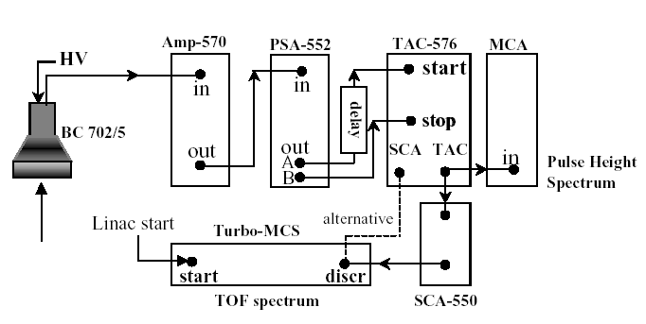
Figure1: Neutron Gamma Separation Circuit
A.K.M. MOINUL H. MEAZE TERM PARER ON PHENOMENOLOGY

C. With Turbo MCS and CAMAC
Figure 2 shows the configuration of the CAMAC and Turbo MCS systems in parallel operation. The above described system was in further improved with CAMAC data acquisition, control system and sample changer (SC) mechanism. The CAMAC part contains the blocks:
1. TE is main time encoder, which has 4096 channels with minimal dwell time
0.5 μs.
2. MEM16K is a memory of 16K capacity, which collects the TOF spectra during a measurement.
3. TTL/NIM module is used as bilateral converter of signals and for remote control purposes if necessary.
4. Block BMPI send request to change sample for SC control block and interrupts the measurement until the next sample will reach its position.
5. SC control block may operate in automatic (normal) and manual modes. In the automatic mode it is controlled by software via BMPI. In the manual mode one can move SC to any desired position by pressing the relevant knob on a front panel of that block. This mode is usually applied during the sample downloading.
6. Detector number encoder allows the data taking from up to 4 detectors simultaneously.
7. Decimal counter has 4 independent inputs and the relevant displays for data and control signals. It is used for accumulation of the monitor counts for each position of SC and for control of duration of exposition for each sample. All these are shown in the figures 2.
D. Sample Changer
The schema of the Sample Changer system is shown in fig.3. This is disc with 4 symmetrically round holds; each one is of 8 cm in diameter. First figure of 3 is inside view of the 4 samples changer. Second figure of 3 is outside view. The system rotates relatively to its own central axis and allows automatically the accumulation of data from up to 4 different samples in one run after setting the time exposition time individually for each sample. Thus, the sample changer provides economic and timesaving

MEASUREMENTS OF NEUTRON--- TERM PAPRER ON PHENOMENOLOGY

measurement. Moreover, the automatic control allows avoiding the systematic errors due to the fluctuation of the neutron beam intensity. The four-position sample changer can be used with different samples: solid samples as well as liquid or powder ones shrouded in special cassettes. The disc cover has two control and management windows and another one for samples downloading. All of them are transparent and pressurized. The beam transmission windows – one in the fixed disk of SC, another in a top of cover are covered with aluminum foil and pressurized also. The movement of the mobile disk with samples is performed by the electric motor with the build – in reduction gearbox. The time of movement between two neighboring positions is 10 sec. The mobile disk moves only in one direction, like revolver. This decreases the backlash in fixing of a sample position.
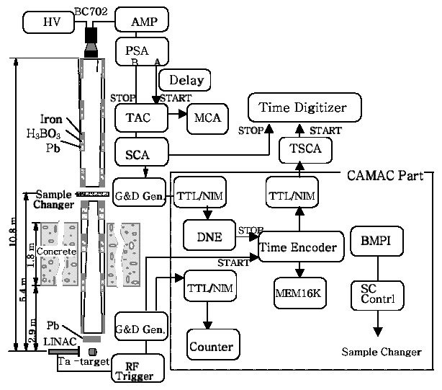
Figure2: All parts of the Apparatus

A.K.M. MOINUL H. MEAZE TERM PARER ON PHENOMENOLOGY

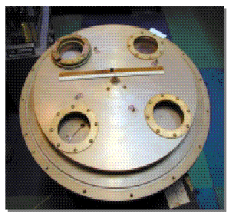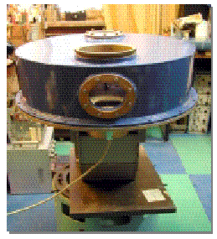
Figure 3: Sample Changer (Inner side and Outer side)
IV. ANALYSING DATA
We have analyzed the samples hafnium and zirconium in order to get total cross section of neutron. The samples contain following properties:
Name of the Sample | Symbol of Sample | Area of the Sample, A/ | Thickness of the Sample, x  (mm) | Atomic weight of Element, A  (amu) | Density, ρ  (g-cm⁻³)
Hafnium | Hf | 5cmx5cm | 0.5 | 178.49 | 13.30
Zirconium | Zr | 10cmx10cm | 0.5 | 091.22 | 06.49
Table 1: Properties of Hf and Zr
Before placing sample we have measured the area and thickness of the samples. I have taken the values of atomic weight and density of these elements from the website [6].
A. Neutron Counts
In our experiment when neutron hit the samples hafnium and zirconium and reached to the detector we counted the number of neutrons and when neutron passed to the detector without hitting the sample again we have counted. After summing all these counts we plotted these counts versus channel number.
MEASUREMENTS OF NEUTRON--- TERM PAPRER ON PHENOMENOLOGY

These graphs are shown below (in figures 4 and 5)
Figure4: Channel Vs Counts for Hf Figure5: Channel Vs Counts for Zr

B. Background Measurement
For background measurement we have used In, Cd and Co sheet because the resonance peak of these samples are well defined and sharp
Fig.6: Background fitting for Notch Filter Fig.7: Background fitting for Hf

A.K.M. MOINUL H. MEAZE TERM PARER ON PHENOMENOLOGY

For these fittings we have used the polynomial fitting function
$y=a+\text{bx}$ (12)
After normalizing by the equation
$N^{2}\int{y(I)\text{dI}=1}$ (13)
and by using same polynomial equation we fitted with our Hf data. The hafnium sample fitted figure is shown above (figure 7).
C. Measurement of Flight Path and Delay Time
As in our Hf sample beam we see that there is some resonances peak. At first we have to find exact channel numbers for each peak. That’s why to find this channel number we have fitted every peak respectively with the Lorenzian fitting function [7]
$y=y_{0}+\frac{2\text{Aw}}{π\left\{w^{2}+4(x−x_{c})^{2}\right\}}$ (14)
The fitted constants are: y0, xc, w and A. The meaning of these constants is offset, center, width and area respectively. All these graphs are shown in the figures 8-11.We took all these resonances from these graphs. For obtain flight path (L) and delay time (τ) we have used least square fitting method. We converted the channel number into energy E in eV by using the following equation:
$E=\frac{(\text{72}\text{.}3×L)^{2}}{(I×Δt)^{2}}=\frac{(\text{72}\text{.}3×\text{10}\text{.}8)^{2}}{(I×\text{.}5)^{2}}$ (15)
where L is the time of flight in m and Δt is the channel width in μS.
The data is used to find the flight path L and delay time τ in the following equation by the least square fitting method
$I=\frac{\text{72}\text{.}3×L}{Δt×\sqrt{E}}+\frac{τ}{Δt}$ (16)
If we let
$Y=Δ\text{tI}$ (17)
$X=\frac{\text{72}\text{.}3}{\sqrt{E}}$ (18)

MEASUREMENTS OF NEUTRON--- TERM PAPRER ON PHENOMENOLOGY

Figures (8-11): Lorenzian Fittings

A.K.M. MOINUL H. MEAZE TERM PARER ON PHENOMENOLOGY

then [8]
$τ=\frac{1}{Δ}(\sum{X^{2}}\sum{Y}−\sum{X}\sum{\text{XY}})$ (19)
$L=\frac{1}{Δ}(N\sum{\text{XY}}−\sum{X}\sum{Y})$ (20)
$Δ=N\sum{X^{2}}−(\sum{X})^{2}$ (21)
By using above equations we got N=4, $L=(\text{10}\text{.}\text{800}±0\text{.}\text{020})m$ and $τ=(1\text{.}\text{540}±0\text{.}\text{001})μS$.
The fitted graph is shown below (figure 12):

Figure 12: Least square fitting

MEASUREMENTS OF NEUTRON--- TERM PAPRER ON PHENOMENOLOGY

V. RESULTS
By using effective values of energy in eV unit and cross sections in barn
(1b=10⁻²⁴ cm²) we plotted our results. The results are shown in the following graphs. The figure 13 shows energy versus neutron total cross section for hafnium and figure 14 shows energy versus neutron total cross section for zirconium.

Figure13: Results for Hf Figure13: Results for Zr

VI. DISCUSSION
In this term paper I have presented my preliminary analyzed total neutron cross section results of the samples hafnium and zirconium. I have covered the energy from 0.1eV to 100 eV. In the case of hafnium it shows that up to 10 eV our result is coincide with evaluated nuclear data file. In the case of zirconium our cross sections are near to the nuclear data file but our statistical error is so high. To reduce error and also to obtain good results we need additional data and I hope I’ll measure again these samples and it will possible to show our new good results in near future.

A.K.M. MOINUL H. MEAZE TERM PARER ON PHENOMENOLOGY

_______________________________________________________________
[1] Evaluated Nuclear Data File, Available at http://atom.kaeri.re.kr/ or http://www2.bnl.gov/ton
[2] Irving Keplan, Nuclear Physics,2nd Ed., Narosa Publishing House, India, 1992 pp. 447-501
[3] Y. Daron & R. C. Block, Nucl Inst & Meth in Phy A485, 585(2002)
[4] G.N. Kim et al, Proceedings 2000 Workshop on Nuclear Data Production and Evaluation, PAL, Pohang, pp. 3-11
[5] V. Kovalchul et al, Proceedings 2000 Workshop on Nuclear Data Production and Evaluation, PAL,Pohang, pp.93-108
[6] Avilable at http://www.cs.ubc.ca/cgi-bin/nph-pertab/element/Hf(Zr)
[7] Yaron Daron, “ Design and Construction of RPI Enhanced thermal neutron target and thermal cross section measurements of research”-Ph. D. thesis, Rensselaer Polytechnic Institute, May 1993
[8] P. R. Bevington, Data Production and Error Analysis for the Physical Science,Case Western Reserve University, USA,1969,pp.93-96

